Sunday | Monday | Tuesday | Wednesday | Thursday | Friday | Saturday
1  May Day | 2 | 3 | 4 | 5  Cinco de Mayo | 6 | 7
8  Mother’s Day | 9 | 10 | 11 | 12 | 13 | 14
15 | 16 | 17 | 18 | 19 | 20 | 21  Armed Forces Day
22 | 23  Victoria Day (Canada) | 24 | 25 | 26 | 27 | 28
29 | 30  Memorial Day | 31

2:30 May Day Craft  3:45 Church Service on YouTube | 9:00 Activity Room  11:00 Story Time  12:00 LDN  1-2:00 Friendly Visits  2-4:00 Rm to Rm Games  6:00 Cards | 9:00 Activity Room  11:00 Story Time  12:00 LDN  1-2:00 Friendly Visits  2-4:00 Rm to Rm Game  6:00 Board Games | 9:00 Activity Room  11:00 Story Time  12:00 LDN  1-2:00 Friendly Visits  2-4:00 Rm to Rm Game  6:00 Craft | 9:00 Activity Room  11:00 Story Time  12:00 LDN  1-2:00 Friendly Visits  2-3:00 Cinco De Mayo Treat  2-4:00 In-Rm Nail Care  6:00 Cards | 9:00 Activity Room  11:00 Game Time  12:00 LDN  1-2:00 Friendly Visits  2-4:00 Rm to Rm Game  3-4:00 Popcorn for All  6:00 Puzzle Day | 9:00 LDN Pass  2:30-4:00 Bingo
2:00 Mother’s Day Treat  3:45 Church Service on YouTube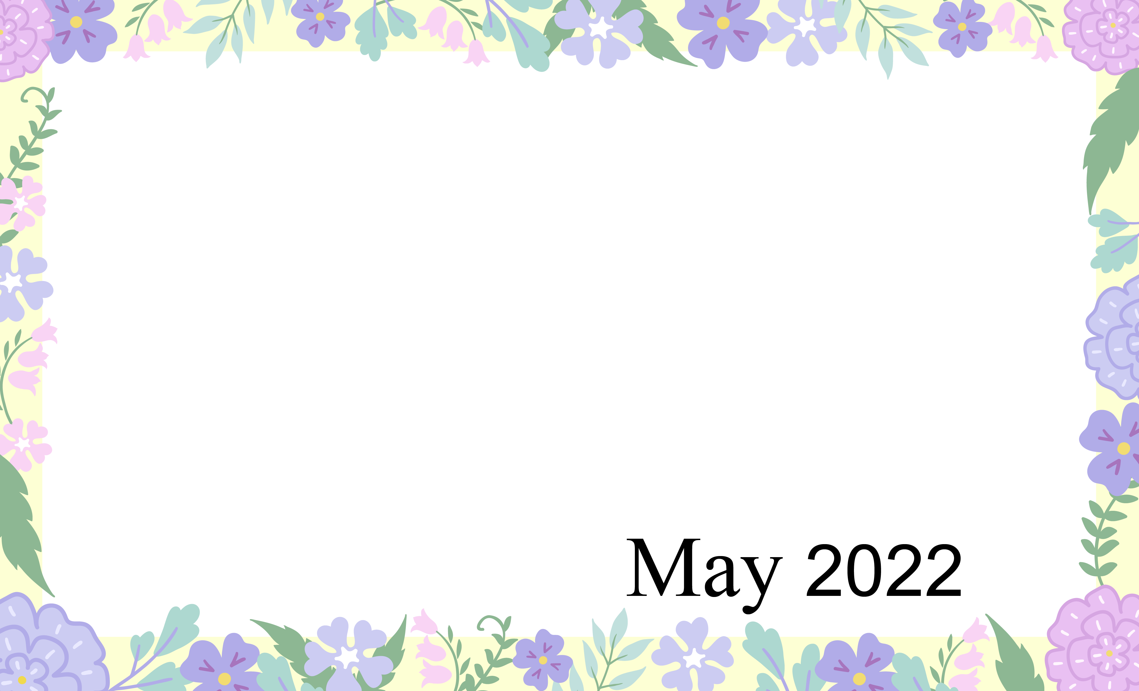 | 9:00 Activity Room  11:00 Story Time  12:00 LDN  1-2:30 Friendly Visits  2:30-4 Bingo  6:00 Cards | 9:00 Activity Room  11:00 Kickball  12:00 LDN  1-2:00 Friendly Visits  2-3:00 Courtyard Time  3-4:00 May B-day Party  6:00 Board Games | 9:00 Activity Room  11:00 Kickball  12:00 LDN  1-2:30 Friendly Visits  2:30-4:00 Bingo  6:00 Craft | 9:00 Activity Room  11:00 Balloon Bating  12:00 LDN  1-2:00 Friendly Visits  2-4:00 Nail Care  6:00 Cards | 9:00 Activity Room  11:00 Game Time  12:00 LDN  1-2:00 Friendly Visits  2-4:00 Word Bingo  6:00 Puzzle Day | 9:00 LDN Pass  2:30-4:00 Bingo
2:00 Cover All Game  3:45 Church Service on YouTube | 9:00 Activity Room  11:00 Story Time  12:00 LDN  1-2:30 Friendly Visits  2:30-4 Bingo  6:00 Cards | 9:00 Activity Room  11:00 Kickball  12:00 LDN  1-2:00 Friendly Visits  2-3:00 Spring Bracelet Craft  3-4:00 Strawberry Shake Social  6:00 Board Games | 9:00 Activity Room  11:00 Story Time  12:00 LDN  1-2:30 Friendly Visits  2:30-4:00 Bingo  6:00 Craft | 9:00 Activity Room  11:00 Balloon Bating  12:00 LDN  1-2:00 Friendly Visits  1:30-2:30 Shrinky Dink Craft  2:30-4:00 Nail Care  6:00 Cards | 9:00 Activity Room  11:00 Game Time  12:00 LDN  1-2:00 Friendly Visits  2-3:00 Show Down  3-4:00 Popcorn for All  6:00 Puzzle Day | 9:00 LDN Pass  2:30-4:00 Bingo
2:00 Cards  3:00 Chips and Dip  3:45 Church Service on YouTube | 9:00 Activity Room  11:00 Story Time  12:00 LDN  1-2:30 Friendly Visits  2:30-4 Bingo  6:00 Cards | 9:00 Activity Room  11:00 Kickball  12:00 LDN  1-2:00 Friendly Visits  2-3:00 Resident Council  3-4:00 Taste of Homes- Fresh Fruit Salad  6:00 Board Games | 9:00 Activity Room  11:00 Story Time  12:00 LDN  1-2:30 Friendly Visits  2:30-4 Bingo  6:00 Craft | 9:00 Activity Room  11:00 Balloon Bating  12:00 LDN  1-2:00 Friendly Visits  1:30-2:30 Paint a Pot  2:30-4 Nail Care  6:00 Cards | 9:00 Activity Room  11:00 Game Time  12:00 LDN  1-2:00 Friendly Visits  2-3:00 Courtyard/Trivia  3-4:00 Courtyard/ Root Beer Floats  6:00 Puzzle Day | 9:00 LDN Pass  2:30-4:00 Bingo
2:00 Dice Game  3:45 Church Service on YouTube | 2-3:30 Dollar Bingo  3:30-4 Memorial Day Service on You Tube | 9:00 Activity Room  11:00 Kickball  12:00 LDN  1-2:00 Friendly Visits  2-3:00 Courtyard/Music  3-4:00 Memory Magic Game  6:00 Board Games | Oakview medical Care Facility
Activities and times are subject to change. Changes will be posted as soon as possible. Large print calendars are available upon request.

