Sunday | Monday | Tuesday | Wednesday | Thursday | Friday | Saturday
 |  |  | 1 | 2 | 3 | 4
5 | 6  Labor Day  Rosh Hashanah Begins | 7 | 8 | 9 | 10 | 11
12  Grandparents Day | 13 | 14 | 15  Yom Kippur Begins | 16 | 17 | 18  Oktoberfest Begins
19 | 20  Sukkot Begins | 21 | 22  Autumn Begins | 23 | 24 | 25
26 | 27 | 28  Simchat Torah Begins | 29 | 30

Oakview medical care Facility |  |  | 9:00 Activity Room  9:00 Activity House  11:00 Bible Study  12:00 LDN  1-2:00 Friendly Visits  2-3:00 Peach Honey Lemonade in the Courtyard  3-4:00 Bingo  6:00 Carnival Picture frame Craft | 9:00 Activity Room  9:00 Activity House  11:00 Balloon Bating  12:00 LDN  1-2:00 Friendly Visits  1:30-3:00 Nail Care  3-4:00 Honey Butter on Texas Toast Treat in the Courtyard  6:00 Cards at the Aquarium | 9:00 Activity Room  9:00 Activity House  11:00 Game Time  12:00 LDN  1-2:00 Friendly Visits  2-3:00 Popcorn in the Courtyard  3-4:00 Bubble tree Wrap Craft  6:00 Puzzle Day at Aquarium | 9:00-12:00 Visits  2:00-3:00 Aviary  3:00-4:00 Bingo
9;00 Aviary  10:00 Activity Room open  11:00-12:00 Game Time  1:00-4:00 Visits | 9:00 Activity Room  9:00 Activity House  11:00 Story Time  12:00 LDN  1-2:00 Friendly Visits  2-3:00 Courtyard/Honey Trivia  3-4:00 Bingo  6:00 Cards at the Aquarium | 9:00 Activity Room  9:00 Activity House  11:00 Kickball  12:00 LDN  1-2:00 Friendly Visits  2-3:00 Apple Slab Pie Social  3-4:00 Stuffed Apple Craft  6:00 Board Games at the Aquarium | 9:00 Activity Room  9:00 Activity House  11:00 Bible Study  12:00 LDN  1-2:00 Friendly Visits  2-3:00 Carmel Apple in the Courtyard  3-4:00 Bingo  6:00 Bird House Craft | 9:00 Activity Room  9:00 Activity House  11:00 Balloon Bating  12:00 LDN  1-2:00 Friendly Visits  1:30-3:00 Nail Care  3-4:00 Honey Vanilla Banana Bread Treat in the courtyard  6:00 Cards at the Aquarium | 9:00 Activity Room  9:00 Activity House  11:00 Game Time  12:00 LDN  1-2:00 Friendly Visits  2-3:00 Courtyard/Trivia  3-4:00 Word Bingo  6:00 Puzzle Day at Aquarium | 9:00-12:00 Visits  2:00-3:00 Aviary  3:00-4:00 Bingo
9;00 Aviary  10:00 Activity Room open  11:00-12:00 Game Time  1:00-4:00 Visits | 9:00 Activity Room  9:00 Activity House  11:00 Story Time  12:00 LDN  1-2:00 Friendly Visits  2-3:00 Courtyard/You Be the Judge  3-4:00 Bingo  6:00 Cards at the Aquarium | 9:00 Activity Room  10-12:00 Car Show  12:00 LDN  1-2:00 Friendly Visits  2-3:00 Monthly Birthday Party  3-4:00 Beehive Game  6:00 Board Games at the Aquarium | 9:00 Activity Room  9:00 Activity House  11:00 Bible Study  12:00 LDN  1-2:00 Friendly Visits  2-3:00 Carmel Corn in the Courtyard  3-4:00 Bingo  6:00 Butterfly Craft | 9:00 Activity Room  9:00 Activity House  11:00 Balloon Bating  12:00 LDN  1-2:00 Friendly Visits  1:30-3:00 Nail Care  3-4:00 Corn Bread with Honey  6:00 Cards at the Aquarium | 9:00 Activity Room  9:00 Activity House  11:00 Game Time  12:00 LDN  1-2:00 Friendly Visits  2-3:00 Popcorn for All in the Courtyard  3-4:00 Showdown  6:00 Puzzle Day at Aquarium | 9:00-12:00 Visits  2:00-3:00 Aviary  3:00-4:00 Bingo
9;00 Aviary  10:00 Activity Room open  11:00-12:00 Game Time  1:00-4:00 Visits | 9:00 Activity Room  9:00 Activity House  11:00 Story Time  12:00 LDN  1-2:00 Friendly Visits  2-3:00 Honey Bun Cake Social  3-4:00 Bingo  6:00 Cards at the Aquarium | 9:00 Activity Room  9:00 Activity House  11:00 Kickball  12:00 LDN  1-2:00 Friendly Visits  2-3:00 Apple Crisp Cookies  3-4:00 Apple Bubble Wrap Painting  6:00 Board Games at the Aquarium | 9:00 Activity Room  9:00 Activity House  11:00 Bible Study  12:00 LDN  1-2:00 Friendly Visits  2-3:00 Finger Print Bee Craft  3-4:00 Bingo  6:00 Fall Bracelet Craft | 9:00 Activity Room  9:00 Activity House  11:00 Balloon Bating  12:00 LDN  1-2:00 Friendly Visits  1:30-3:00 Nail Care  3-4:00 Apple Window Craft  6:00 Cards at the Aquarium | 9:00 Activity Room  9:00 Activity House  11:00 Game Time  12:00 LDN  1-2:00 Friendly Visits  2-3:00 Courtyard/Short Stories  3-4:00 Apple Tissue Paper Craft  6:00 Puzzle Day at Aquarium | 9:00-12:00 Visits  2:00-3:00 Aviary  3:00-4:00 Bingo
9;00 Aviary  10:00 Activity Room open  11:00-12:00 Game Time  1:00-4:00 Visits | 9:00 Activity Room  9:00 Activity House  11:00 Story Time  12:00 LDN  1-2:00 Friendly Visits  2-3:00 Courtyard/Life Stories Game  3-4:00 Bingo  6:00 Cards at the Aquarium | 9:00 Activity Room  9:00 Activity House  11:00 Kickball  12:00 LDN  1-2:00 Friendly Visits  2-3:00 Apple Fritter Social  3-4:00 Apple Yarn Craft  6:00 Board Games at the Aquarium | 9:00 Activity Room  9:00 Activity House  11:00 Bible Study  12:00 LDN  1-2:00 Friendly Visits  2-3:00 Warm Apple Cider in the Courtyard  3-4:00 Bingo  6:00 Dragonfly Craft | 9:00 Activity Room  9:00 Activity House  11:00 Balloon Bating  12:00 LDN  1-2:00 Friendly Visits  1:30-3:00 Nail Care  3-4:00 Apple Paper Craft  6:00 Cards at the Aquarium
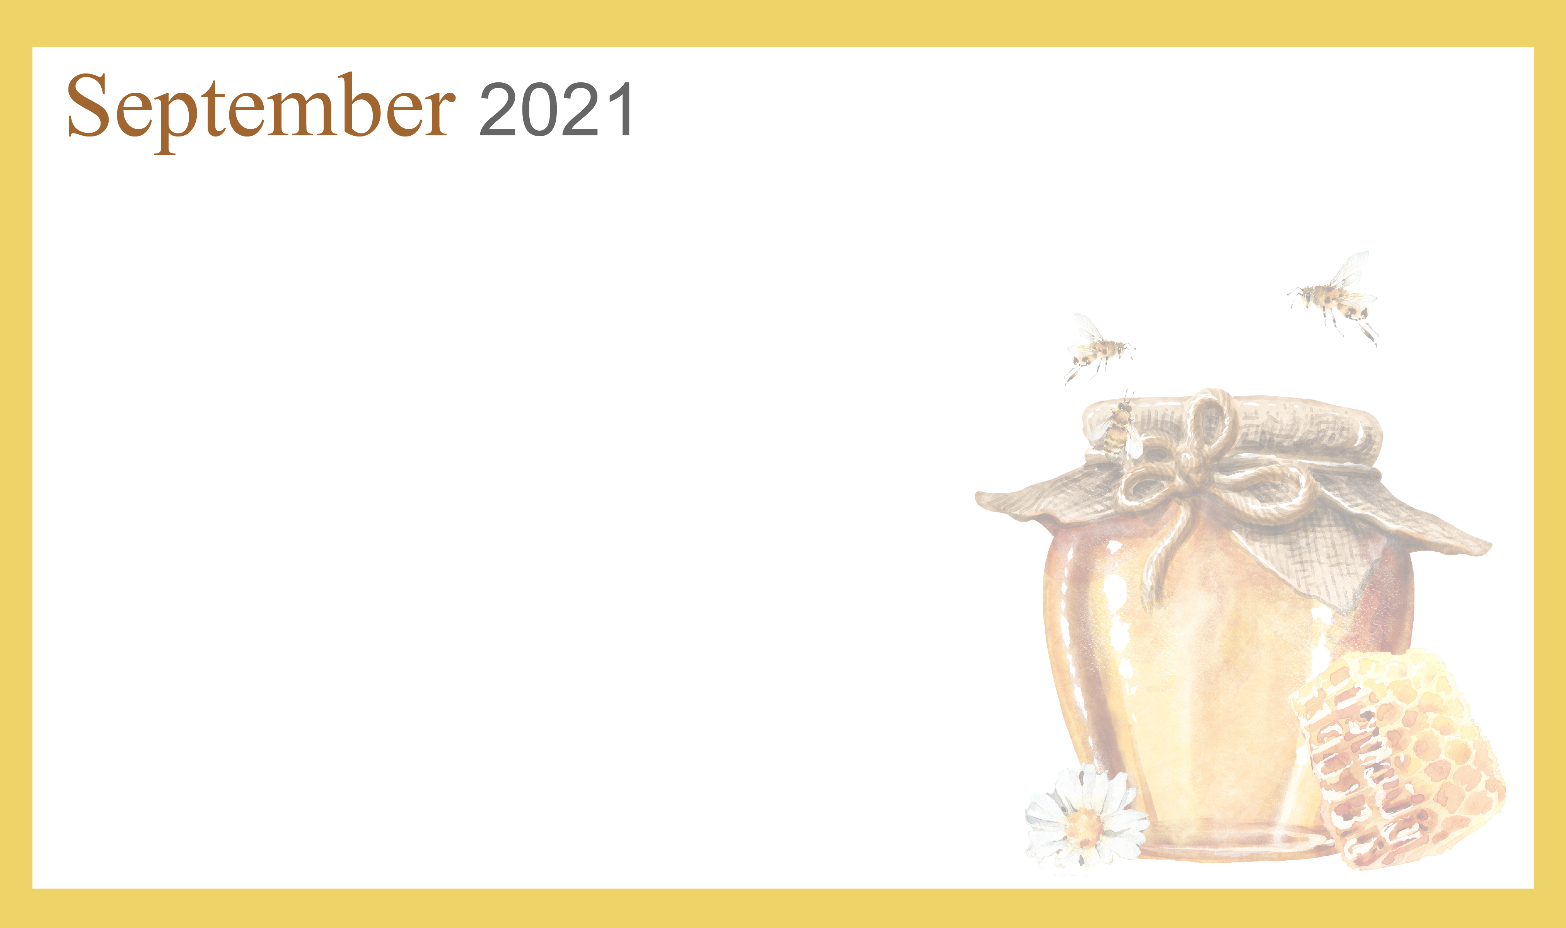
Activities and time are subject to change. Changes will be posted as soon as possible. Large print calendars are available upon request.

