Sunday | Monday | Tuesday | Wednesday | Thursday | Friday | Saturday
 |  |  |  | 1  Canada Day | 2 | 3
4  Independence Day (US) | 5 | 6 | 7 | 8 | 9 | 10
11 | 12 | 13 | 14 | 15 | 16 | 17
18 | 19 | 20 | 21 | 22 | 23 | 24
25 | 26 | 27 | 28 | 29 | 30 | 31

Add a title or monthly theme here. |  |  |  | 9:00 Activity Room  9:00 Activity House  11:00 Exercise  12:00 LDN  1-2:00 Friendly Visits  1:30-3:00 Nail Care  3-4:00 Strawberry Short Cake Social  6:00 Cards at the Aquarium | 9:00 Activity Room  9:00 Activity House  11:00 Game Time  12:00 LDN  1-2:00 Friendly Visits  2-3:00 4th of July Necklace Craft  3-4:00 Word Bingo  6:00 Puzzle Day at Aquarium | 9:00 LDN & Puzzle Packs  10:00-12:00 Friendly Visits  2-3:00 Aviary  3:-4:00 Bingo
9:00-12:00 Friendly Visits  2-3:00 Gospel –Sing- A Long/Virtual Church Service  3:-4:00 Patriotic Party in the Courtyard | 9:00 Activity Room  9:00 Activity House  11:00 Story Time  12:00 LDN  1-2:00 Friendly Visits  2-3:00 Courtyard/History of the 4th of July  3-4:00 Bingo  6:00 Cards at the Aquarium | 9:00 Activity Room  9:00 Activity House  11:00 Kickball  12:00 LDN  1-2:00 Friendly Visits  2-3:00 Red White and Blue Rice Krispy Social  3-4:00 Courtyard/Trivia  6:00 Board Games | 9:00 Activity Room  9:00 Activity House  11:00 Bible Study  12:00 LDN  1-2:00 Friendly Visits  2-3:00 Courtyard/ Name 5 Game  3-4:00 Bingo  6:00 Patriotic Turtle Craft | 9:00 Activity Room  9:00 Activity House  11:00 Balloon Bating  12:00 LDN  1-2:00 Friendly Visits  1:30-3:00 Nail Care  3-4:00 Dilly Bars in the Courtyard  6:00 Cards at the Aquarium | 9:00 Activity Room  9:00 Activity House  11:00 Game Time  12:00 LDN  1-2:00 Friendly Visits  2-3:00 Popcorn For All  2-3:00 Courtyard Time  3-4:00 Showdown  6:00 Puzzle Day at Aquarium | 9:00 LDN & Puzzle Packs  10:00-12:00 Friendly Visits  2-3:00 Aviary  3:-4:00 Bingo
9:00-12:00 Friendly Visits  2-3:00 Gospel –Sing- A Long/Virtual Church Service  3:-4:00 Left –Right-Center Game | 9:00 Activity Room  9:00 Activity House  11:00 Story Time  12:00 LDN  1-2:00 Friendly Visits  2-3:00 Courtyard/Name that Patriotic Tune  3-4:00 Bingo  6:00 Cards at the Aquarium | 9:00 Activity Room  9:00 Activity House  11:00 Kickball  12:00 LDN  1-2:00 Friendly Visits  2-3:00 Monthly Birthday Social  3-4:00 Star Craft Class  6:00 Cover All at the Aquarium | 9:00 Activity Room  9:00 Activity House  11:00 Bible Study  12:00 LDN  1-2:00 Friendly Visits  2-3:00 Daiquiri’s in the Courtyard  3-4:00 Bingo  6:00 Bracelet Making Craft | 9:00 Activity Room  9:00 Activity House  11:00 Exercise  12:00 LDN  1-2:00 Friendly Visits  1:30-3:00 Nail Care  3-4:00 Courtyard/Squirt Gun Painting  6:00 Cards at the Aquarium | 9:00 Activity Room  9:00 Activity House  11:00 Game Time  12:00 LDN  1-2:00 Friendly Visits  2-3:00 Fruit Pizza Social  3-4:00 Memory Magic  6:00 Puzzle Day at Aquarium | 9:00 LDN & Puzzle Packs  10:00-12:00 Friendly Visits  2-3:00 Aviary  3:-4:00 Bingo
9:00-12:00 Friendly Visits  2-3:00 Gospel –Sing- A Long/Virtual Church Service  3:-4:00 Ice Cream Sandwiches in the Courtyard | 9:00 Activity Room  9:00 Activity House  11:00 Story Time  12:00 LDN  1-2:00 Friendly Visits  2-3:00 Sunset Painting Craft  3-4:00 Green Music on the Patio  6:00 Cards at the Aquarium | 9:00 Activity Room  9:00 Activity House  11:00 Kickball  12:00 LDN  1-2:00 Friendly Visits  2-3:00 Skeleton Hangman Game  3-4:00 Courtyard/Trivia/Bomb Pops  6:00 Board Games | 9:00 Activity Room  9:00 Activity House  11:00 Bible Study  12:00 LDN  1-2:00 Friendly Visits  2-3:00 Reading in the Courtyard  3-4:00 Bingo  6:00 Frog Hanger Craft | 9:00 Activity Room  9:00 Activity House  11:00 Balloon Bating  12:00 LDN  1-2:00 Friendly Visits  1:30-3:00 Nail Care  3-4:00 Courtyard/Mason County History  6:00 Cards at the Aquarium | 9:00 Activity Room  9:00 Activity House  11:00 Game Time  12:00 LDN  1-2:00 Friendly Visits  2-3:00 Popcorn For All  2-4:00 Courtyard/Music  6:00 Puzzle Day at Aquarium | 9:00 LDN & Puzzle Packs  10:00-12:00 Friendly Visits  2-3:00 Aviary  3:-4:00 Bingo
9:00-12:00 Friendly Visits  2-3:00 Gospel –Sing- A Long/Virtual Church Service  3:-4:00 Show Down | 9:00 Activity Room  9:00 Activity House  11:00 Story Time  12:00 LDN  1-2:00 Friendly Visits  2-3:00 Courtyard/Campfire Stories  3-4:00 Bingo  6:00 Cards at the Aquarium | 9:00 Activity Room  9:00 Activity House  11:00 Kickball  12:00 LDN  1-2:00 Friendly Visits  2-3:00 Resident Council  3-4:00 Courtyard/Trivia/Ice Cream Cone  6:00 Yahtzee | 9:00 Activity Room  9:00 Activity House  11:00 Bible Study  12:00 LDN  1-2:00 Friendly Visits  2-3:00 Courtyard/Kool Aide Cubes Punch  3-4:00 Bingo  6:00 Wood Beach Frame | 9:00 Activity Room  9:00 Activity House  11:00 Exercise  12:00 LDN  1-2:00 Friendly Visits  1:30-3:00 Nail Care  3-4:00 Courtyard/Hangman  6:00 Cards at the Aquarium | 9:00 Activity Room  9:00 Activity House  11:00 Game Time  12:00 LDN  1-2:00 Friendly Visits  2-4 Board Games in the Courtyard  6:00 Puzzle Day at Aquarium | 9:00 LDN & Puzzle Packs  10:00-12:00 Friendly Visits  2-3:00 Aviary  3:-4:00 Bingo
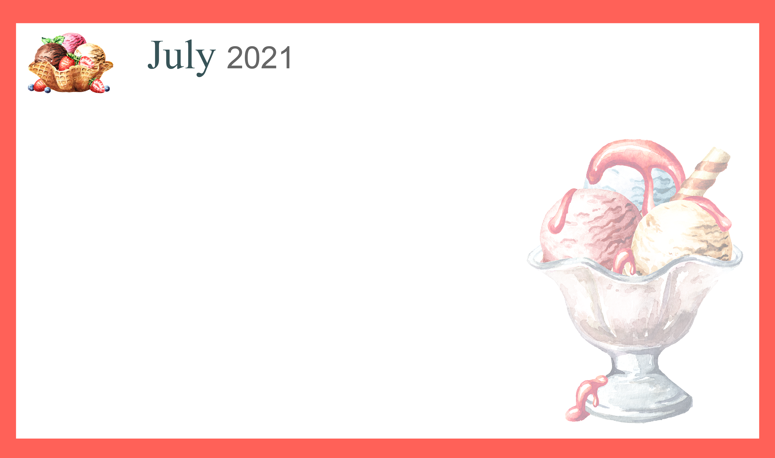
Activities and times are subject to change. Changes will be posted as soon as possible. Large print calendars are available upon request.

