Sunday | Monday | Tuesday | Wednesday | Thursday | Friday | Saturday
1

May Day

2 | 3 | 4 | 5  Cinco de Mayo | 6 | 7 | 8
9  Mother’s Day | 10 | 11 | 12 | 13 | 14 | 15  Armed Forces Day
16  Shavuot Begins | 17 | 18 | 19 | 20 | 21 | 22
23 | 24  Victoria Day (Canada) | 25 | 26 | 27 | 28 | 29
30 | 31  Memorial Day

Oakview Medical Care Facility |  |  |  |  |  | 9:00 LDN & Puzzle Packets  10:00-12:00 Friendly Visits  3-4:00 May Day Basket Craft
9:00 Aviary  10:00-12:00 Friendly Visits  3:-4:00 Gospel –Sing- A Long/Virtual Church Service | 9:00 Activity Room  11:00 Game Time  12:00 LDN  1-2:00 Friendly Visits  2-3:00 Peanut Butter Crunch Cookie Treat  3-4:00 Bingo  6:00 Room to Room Cards | 9:00 Activity Room  11:00 Exercise  12:00 LDN  1-2:00 Friendly Visits  2-3:00 Court Yard/Reminisce  3-4:00 Silhouette Flower Craft  6:00 Room to Room iPad Game | Cinco de Mayo  9:00 Activity Room  11:00 Bible Study  12:00 LDN  1-2:00 Friendly Visits  2-3:00 Chips and Salsa Treat  3-4:00 Bingo  6:00 Room to Room Craft | 9:00 Activity Room  11:00 Exercise  12:00 LDN  1-2:00 Friendly Visits  1:30-3:00 Nail Care  3-4:00 Trivia in the Courtyard  6:00 Room to Room Cards | 9:00 Activity Room  11:00 Game Time  12:00 LDN  1-2:00 Friendly Visits  2-3:00 Popcorn For All  3-4:00 Movie-Viva Las Vegas  6:00 Room to Room iPad Game | 9:00 LDN & Puzzle Packets  10:00-12:00 Friendly Visits  3-4:00 Bingo
Happy Mother’s Day  9:00 Aviary  10:00-12:00 Friendly Visits  3:-4:00 Mother’s Day Social | 9:00 Activity Room  11:00 Game Time  12:00 LDN  1-2:00 Friendly Visits  2-3:00 Peach Dump Cake Treat  3-4:00 Bingo  6:00 Room to Room Cards | 9:00 Activity Room  11:00 Exercise  12:00 LDN  1-2:00 Friendly Visits  2-3:00 Monthly Birthday Treat  3-4:00 Mind Joggers Game  6:00 Room to Room iPad Game | 9:00 Activity Room  11:00 Bible Study  12:00 LDN  1-2:00 Friendly Visits  2-3:00 Oatmeal Raisin Cookie snack  3-4:00 Bingo  6:00 Room to Room Craft | 9:00 Activity Room  11:00 Exercise  12:00 LDN  1-2:00 Friendly Visits  1:30-3:00 Nail Care  3-4:00 Name 5 Game in the Courtyard  6:00 Room to Room Cards | 9:00 Activity Room  11:00 Game Time  12:00 LDN  1-2:00 Friendly Visits  2-3:00 Ice Cream Sandwich Treat  3-4:00 May Flower Craft  6:00 Room to Room iPad Game | 9:00 LDN & Puzzle Packets  10:00-12:00 Friendly Visits  3-4:00 Bingo
9:00 Aviary  10:00-12:00 Friendly Visits  3:-4:00 Gospel- Sing- A Long/Virtual Church Service | Nat’l Cherry Cobbler Day  9:00 Activity Room  11:00 Game Time  12:00 LDN  1-2:00 Friendly Visits  2-3:00 Cherry Cobbler Treat  3-4:00 Bingo  6:00 Room to Room Cards | 9:00 Activity Room  11:00 Exercise  12:00 LDN  1-2:00 Friendly Visits  2-3:00 Cheesy Home Fries  3-4:00 Courtyard and Sing- A -Longs  6:00 Room to Room iPad Game | Nat’l Devil’s Food Cake  9:00 Activity Room  11:00 Bible Study  12:00 LDN  1-2:00 Friendly Visits  2-3:00 Devil’s Food Cake Treat  3-4:00 Bingo  6:00 Room to Room Craft | 9:00 Activity Room  11:00 Exercise  12:00 LDN  1-2:00 Friendly Visits  1:30-3:00 Nail Care  3-4:00 Music in the Courtyard  6:00 Room to Room Cards | 9:00 Activity Room  11:00 Game Time  12:00 LDN  1-2:00 Friendly Visits  2-3:00 Popcorn For All  3-4:00 Word Bingo  6:00 Room to Room iPad Game | 9:00 LDN & Puzzle Packets  10:00-12:00 Friendly Visits  3-4:00 Bingo
9:00 Aviary  10:00-12:00 Friendly Visits  3:-4:00 Gospel- Sing- A Long/Virtual Church Service | 9:00 Activity Room  11:00 Virtual Trip to China  12:00 LDN  1-2:00 Friendly Visits  2-3:00 Chicken Fried Rice Treat  3-4:00 Bingo  6:00 Room to Room Cards | 9:00 Activity Room  11:00 Exercise  12:00 LDN  1-2:00 Friendly Visits  2-3:00 Courtyard/Family Feud  3-4:00 Resident Council  6:00 Room to Room iPad Game | 9:00 Activity Room  11:00 Bible Study  12:00 LDN  1-2:00 Friendly Visits  2-3:00 Courtyard /Yoga  3-4:00 Bingo  6:00 Room to Room Craft | 9:00 Activity Room  11:00 Exercise  12:00 LDN  1-2:00 Friendly Visits  1:30-3:00 Nail Care  3-4:00 Name that Tune in the Courtyard  6:00 Room to Room Cards | 9:00 Activity Room  11:00 Game Time  12:00 LDN  1-2:00 Friendly Visits  2-3:00 Slushes in the Courtyard  3-4:00 Horse Race Game/Courtyard  6:00 Room to Room iPad Game | 9:00 LDN & Puzzle Packets  10:00-12:00 Friendly Visits  3-4:00 Bingo
9:00 Aviary  10:00-12:00 Friendly Visits  3:-4:00 Gospel- Sing- A Long/Virtual Church Service | Memorial Day  9-12:00 Friendly Visits  2-3:00 Red White and Blue Treat  3-4:00 Courtyard/ Remembering Our Veterans
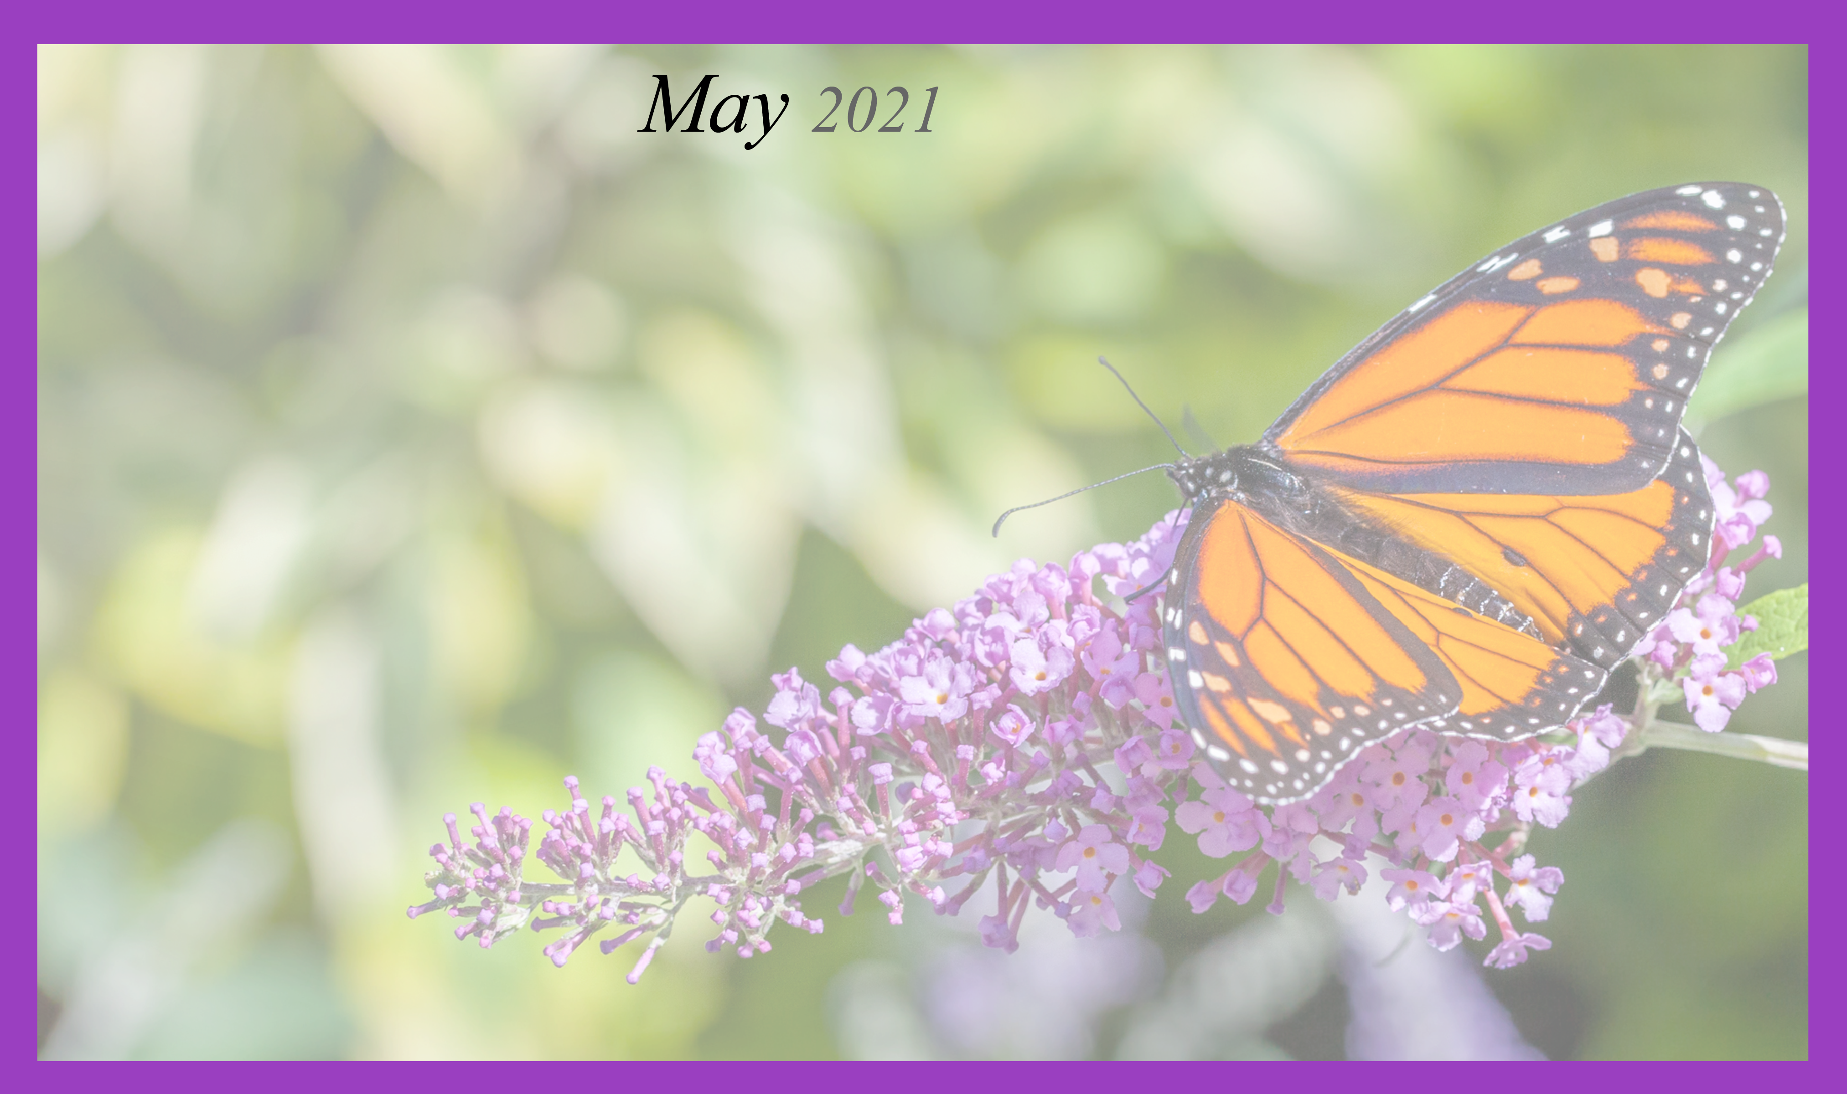
Activities and times are subject to change. Changes will be posted as soon as possible. Large print calendars are available upon request.

