Sunday | Monday | Tuesday | Wednesday | Thursday | Friday | Saturday
 | 1 | 2 | 3 | 4 | 5 | 6
7 | 8 | 9 | 10 | 11 | 12 | 13
14  Daylight Saving Time Begins | 15 | 16 | 17  St. Patrick’s Day | 18 | 19 | 20  Spring Begins
21 | 22 | 23 | 24 | 25 | 26 | 27  Passover Begins
28  Palm Sunday | 29 | 30 | 31

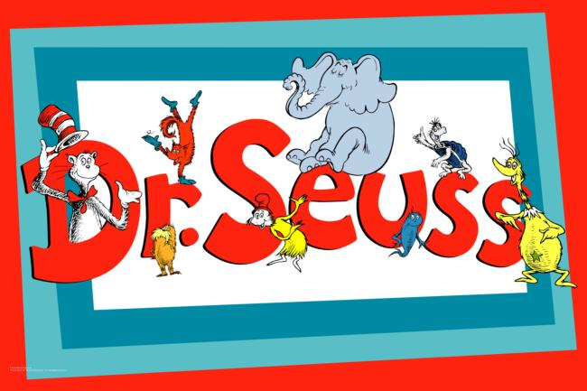 | 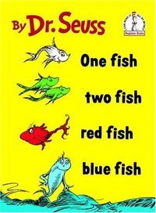  9:00 Activity Room  11:00 Game Time  12:00 LDN and Bingo Numbers  1-2:00 Friendly Visits  2-3:00 Rainbow Fish Snack  3-4:00 1 Fish 2 Fish Showdown  6:00 Room to Room Activities |   9:00 Activity Room  11:00 Exercise  12:00 LDN and Bingo Numbers  1-2:00 Friendly Visits  2-3:00 Cat in the Hat Jell-o Cup  3-4:00 Roll & Color Dice Game  6:00 Room to Room Activities | 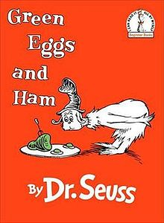  9:00 Activity Room  11:00 Game Time  12:00 LDN and Bingo Numbers  1-2:00 Friendly Visits  2-3:00 Green Eggs & Ham Treat  3-4:00 Showdown  6:00 Room to Room Activities | 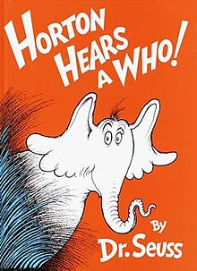  9:00 Activity Room  11:00 Exercise  12:00 LDN and Bingo Numbers  1-2:00 Friendly Visits  2-4:00 Nail Care  3-4:15 Elephant Ear Social  6:00 Room to Room Activities | 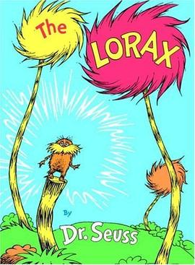  9:00 Activity Room  11:00 Lorax Craft  12:00 LDN and Bingo Numbers  1-2:00 Friendly Visits  2-3:00 Popcorn for All  3-4:15 The Lorax Movie  6:00 Room to Room Activities | 9:00 LDN & Puzzle Packets  10:00 Morning Joe & Cocoa Cart  11:00 Friendly Visits  3-4:00 Show Down
9:00 Aviary  10:00 Morning Joe & Cocoa Cart  11:00 Friendly Visits  3-4:00 Game Time | P.J Day    9:00 Activity Room  11:00 Game Time  12:00 LDN and Bingo Numbers  1-2:00 Friendly Visits  2-3:00 Milk and Cookie Treat  3-4:00 Bedtime Stories  6:00 Room to Room Activities | Crazy Hair Day    9:00 Activity Room  11:00 Exercise  12:00 LDN and Bingo Numbers  1-2:00 Friendly Visits  2-3:00 History of the Hair Styles  3-4:00 Monthly Birthday Treat  6:00 Room to Room Activities | 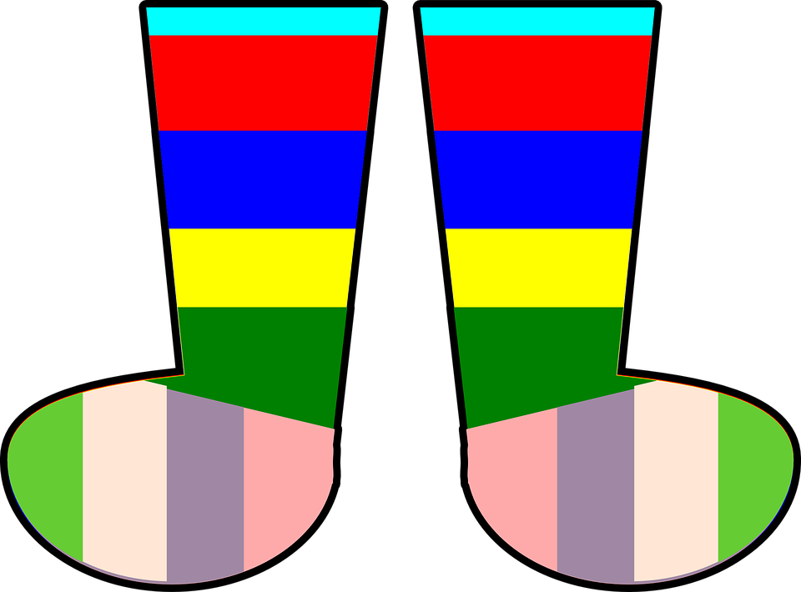  Wacky Sock Day  9:00 Activity Room  11:00 Game Time  12:00 LDN and Bingo Numbers  1-2:00 Friendly Visits  2-3:00 Cherry Coke  3-4:00 50’s Sock Hop Music  6:00 Room to Room Activities | Goofy Hat Day    9:00 Activity Room  11:00 Exercise  12:00 LDN and Bingo Numbers  1-2:00 Friendly Visits  2-4:00 Nail Care  3-4:15 Funny Hats Around the World  6:00 Room to Room Activities | Gaudy Attire Day    9:00 Activity Room  11:00 Game Time  12:00 LDN and Bingo Numbers  1-2:00 Friendly Visits  2-3:00 M&M Cookie Treat  3-4:15 Fashion Show on the Big Screen  6:00 Room to Room Activities | 9:00 LDN & Puzzle Packets  10:00 Morning Joe & Cocoa Cart  11:00 Friendly Visits  3-4:00 Edgar Struble Presents the Kenny Rodgers Band
9:00 Aviary  10:00 Morning Joe & Cocoa Cart  11:00 Friendly Visits  3-4:00 Pie Day Social | 9:00 Activity Room  11:00 Game Time  12:00 LDN and Bingo Numbers  1-2:00 Friendly Visits  2-3:00 Rainbow in a Glass Treat  3-4:15 Rainbow Bracelet Craft    6:00 Room to Room Activities | 9:00 Activity Room  11:00 Exercise  12:00 LDN and Bingo Numbers  1-2:00 Friendly Visits  2-3:00 Pot of Gold Treat  3-4:00 Shamrock Showdown    6:00 Room to Room Activities | 9:00 Activity Room  11:00 Game Time  12:00 LDN and Bingo Numbers  1-2:00 Friendly Visits  2-3:00 Leprechaun Parfait Treat  3-4:00 Leprechaun Craft    6:00 Room to Room Activities | 9:00 Activity Room  11:00 Exercise  12:00 LDN and Bingo Numbers  1-2:00 Friendly Visits  2-4:00 Nail Care  3-4:15 Rainbow Dice Game  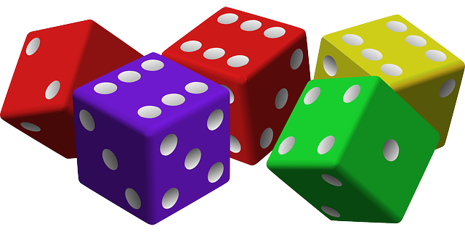  6:00 Room to Room Activities | 9:00 Activity Room  11:00 Game Time  12:00 LDN and Bingo Numbers  1-2:00 Friendly Visits  2-3:00 Popcorn for All  3-4:15 Wizard of Oz Movie  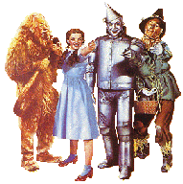  6:00 Room to Room Activities | 9:00 LDN & Puzzle Packets  10:00 Morning Joe & Cocoa Cart  11:00 Friendly Visits  3-4:00 Show Down
9:00 Aviary  10:00 Morning Joe & Cocoa Cart  11:00 Friendly Visits  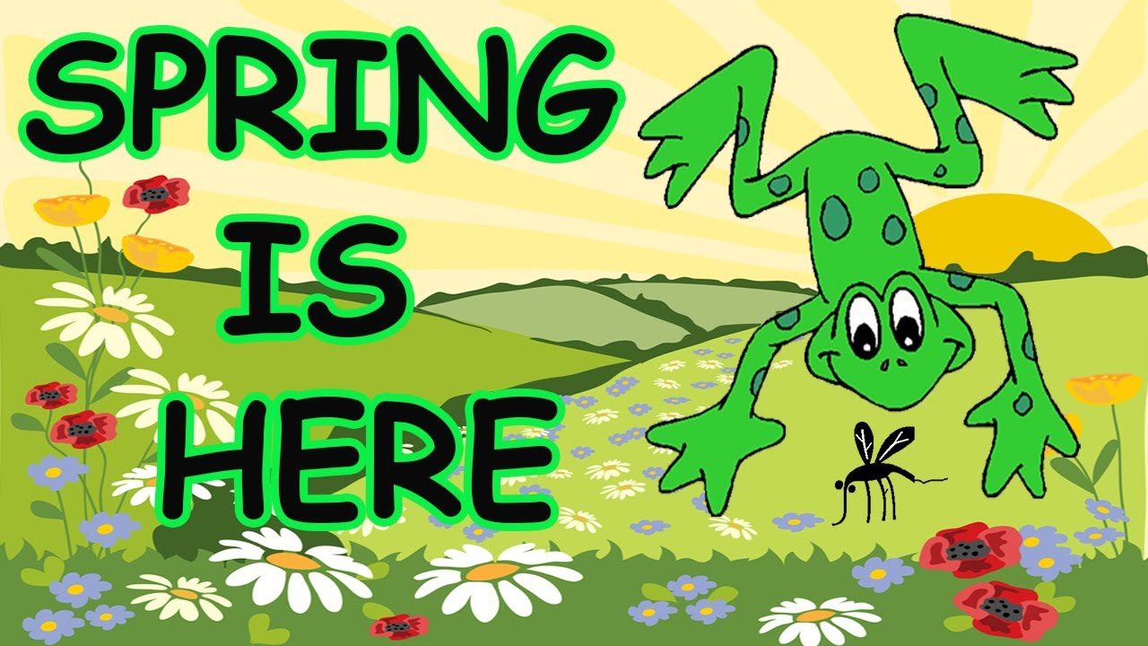  3-4:00 Game Time | 9:00 Activity Room  11:00 Game Time  12:00 LDN and Bingo Numbers  1-2:00 Friendly Visits  2-3:00 Fruit Cup Treat  3-4:00 3D Spring Craft  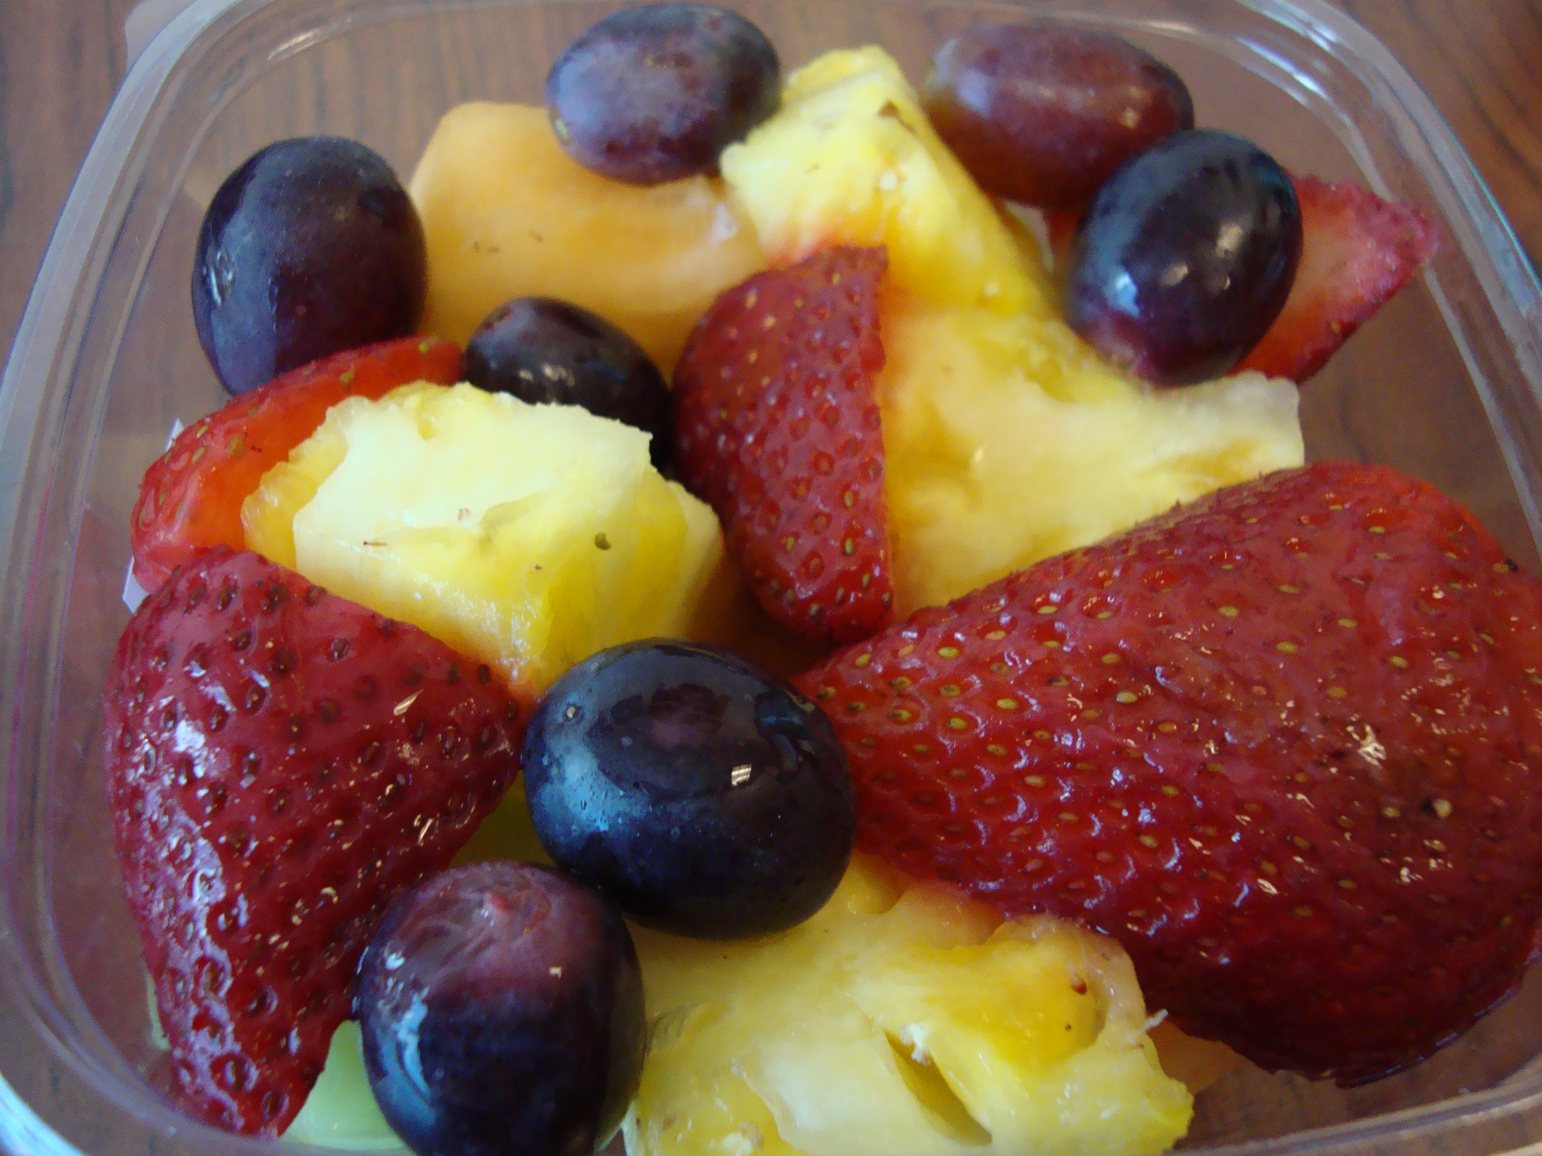  6:00 Room to Room Activities | 9:00 Activity Room  11:00 Exercise  12:00 LDN and Bingo Numbers  1-2:00 Friendly Visits  2-3:00 Spring Cookies Treat  3-4:00 Spring Jeopardy  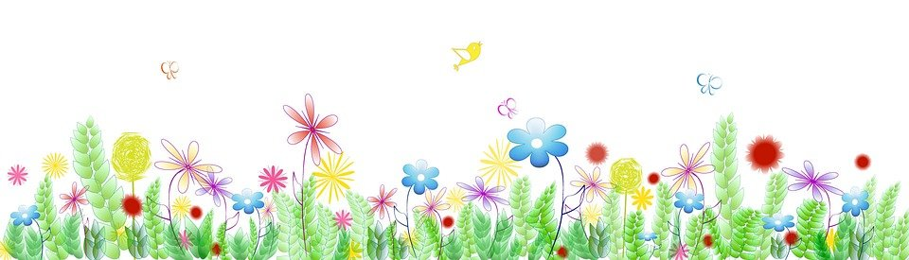  6:00 Happy Spring Craft | 9:00 Activity Room  11:00 Game Time  12:00 LDN and Bingo Numbers  1-2:00 Friendly Visits  2-3:00 Pink Lemonade Flower cupcakes  3-4:00 Hello Spring Craft  6:00 Room to Room Activities | 9:00 Activity Room  11:00 Exercise  12:00 LDN and Bingo Numbers  1-2:00 Friendly Visits  2-4:00 Nail Care  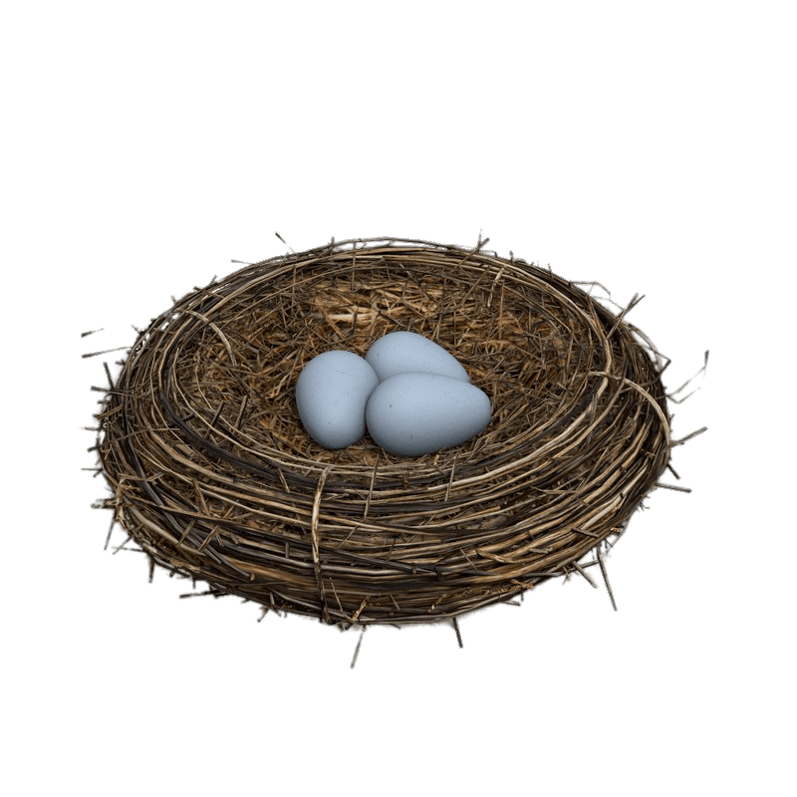  3-4:15 Nest Treat  6:00 Bird Nest Craft | 9:00 Activity Room  11:00 Game Time  12:00 LDN and Bingo Numbers  1-2:00 Friendly Visits  2-3:00 Ice Cream Treat  3-4:15 Memory Magic    6:00 Room to Room Activities | 9:00 LDN & Puzzle Packets  10:00 Morning Joe & Cocoa Cart  11:00 Friendly Visits  3-4:00 Show Down
9:00 Aviary  10:00 Morning Joe & Cocoa Cart  11:00 Friendly Visits  3-4:15 Game Time | 9:00 Activity Room  11:00 Game Time  12:00 LDN and Bingo Numbers  1-2:00 Friendly Visits  2-3:00 Dirt Cake Treat  3-4:00 Plant Flowers  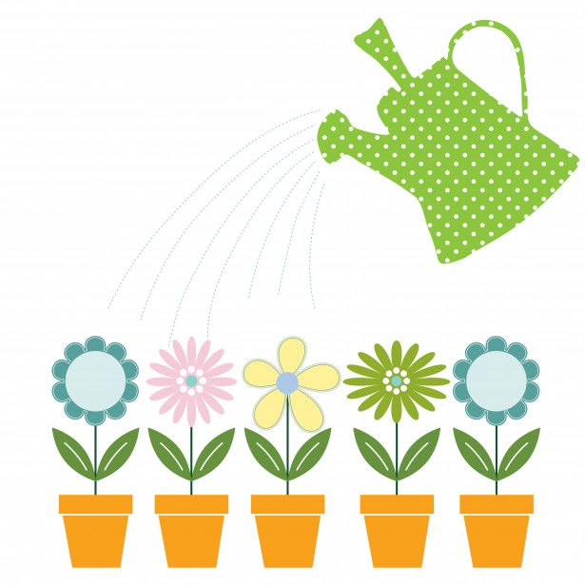  6:00 Bug Craft | 9:00 Activity Room  11:00 Exercise  12:00 LDN and Bingo Numbers  1-2:00 Friendly Visits  2-3:00 Water Bucket Treat  3-4:00 Resident council  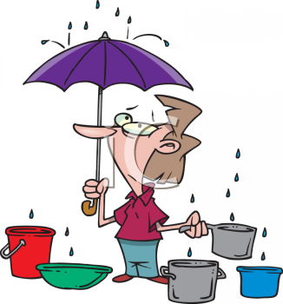  6:00 Room to Room Activities | 9:00 Activity Room  11:00 Game Time  12:00 LDN and Bingo Numbers  1-2:00 Friendly Visits  2-3:00 Rain Drop Cookie Treat  3-4:00 Singing in the Rain Movie    6:00 Umbrella Craft | Oakview Medical Care Facility
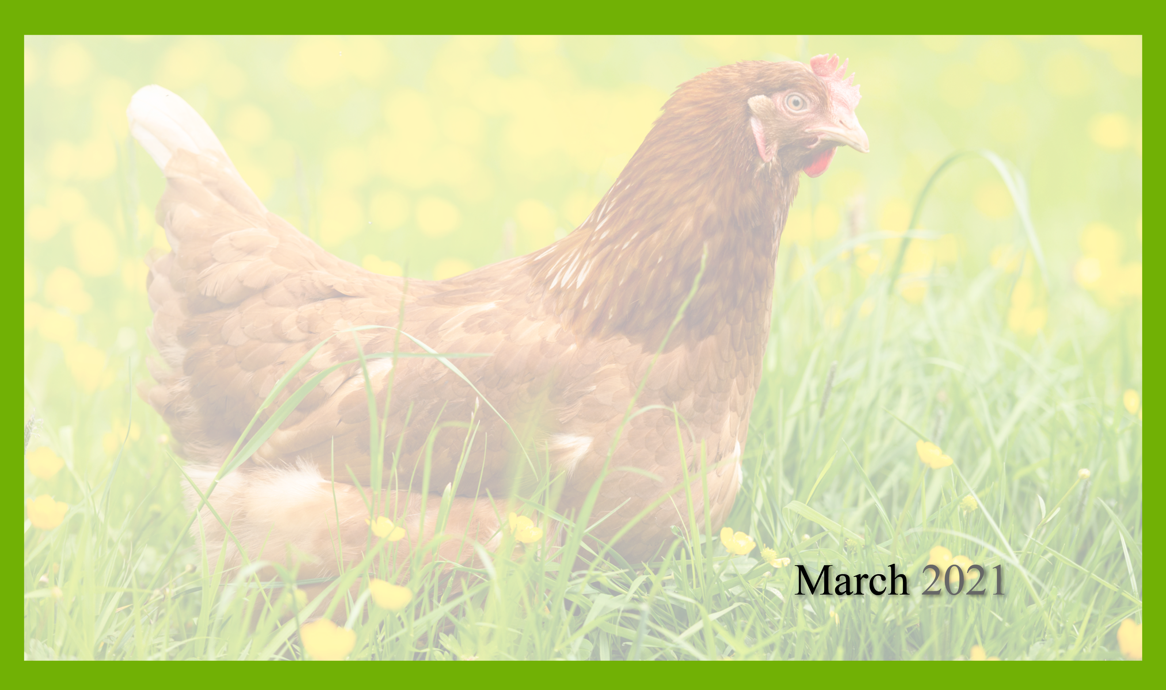
Activities and times are subject to change. Changes will be posted as soon as possible. Large print calendars are available upon request.

