Sunday | Monday | Tuesday | Wednesday | Thursday | Friday | Saturday
 | 1 | 2  Groundhog Day | 3 | 4 | 5 | 6
7 | 8 | 9 | 10 | 11 | 12  Chinese New Year (Year of the Ox) | 13
14  Valentine’s Day | 15  Presidents’ Day | 16  Mardi Gras | 17 | 18 | 19 | 20
21 | 22 | 23 | 24 | 25  Purim Begins | 26 | 27

28

All Activities are in-room and 1:1 with Activity staff at this time. | Hula in the Coola  9:00 Morning Joe & Cocoa Cart    10:00-12:00 Game Time  12:00 Pass Daily News  1:00-2:00 Friendly Visits  1:30-2:30 Daily Bingo Numbers  2:30-3:30 Hawaiian Photo Shoot  3:30-4:15 Hawaiian Meatball Treat  6:00 Aloha Bracelet Craft | Groundhog Day  9:00 Morning Joe & Cocoa Cart    10:00-12:00 Exercise Time  12:00 Pass Daily News  1:00-2:00 Friendly Visits  1:30-2:30 Daily Bingo Numbers  2:30-3:30 Facts about Groundhogs  3:30-4:15 Groundhog Day Treat  6:00 Groundhog Day Craft | Half Winter Day  9:00 Morning Joe & Cocoa Cart    10:00-12:00 Game Time  12:00 Pass Daily News  1:00-2:00 Friendly Visits  1:30-2:30 Daily Bingo Numbers  2:30-3:30 Bird Feeder Craft  3:30-4:15 Half Way Yogurt Treat  6:00 Room to Room Activities | Thank a Mailman Day    9:00 Morning Joe & Cocoa Cart  10:00-12:00 Game Time  12:00 Pass Daily News  1:00-2:00 Friendly Visits  1:30-2:30 Daily Bingo Numbers  2:30-4:15 Nail Care  3:30-4:15 Thank A Mailman Day  6:00 Room to Room Activities | Wear Red Day  9:00 Morning Joe & Cocoa Cart    10:00-12:00 Game Time  12:00 Pass Daily News  1:00-2:00 Friendly Visits  1:30-2:30 Daily Bingo Numbers  2:30-3:30 Popcorn for All  3:30-4:15 Yahtzee on the iPad  6:00 Room to Room Activities | 9:00 Pass Daily News & Puzzle Packets  10:00 Morning Joe & Cocoa Cart  11:00-12:00 Friendly Visits  2:30-4:00 Game Time
10:00 Morning Joe & Cocoa Cart/Pass Devotionals  11:00-12:00 Friendly Visits  2:30-4:00 Game Time | Potato Lovers Day  9:00 Morning Joe & Cocoa Cart    10:00-12:00 Game Time  12:00 Pass Daily News  1:00-2:00 Friendly Visits  1:30-2:30 Daily Bingo Numbers  2:30-3:30 Fry Valentine Craft  3:30-4:15 Potato Skin Tots Treat  6:00 Room to Room Activities | National Pizza Day  9:00 Morning Joe & Cocoa Cart  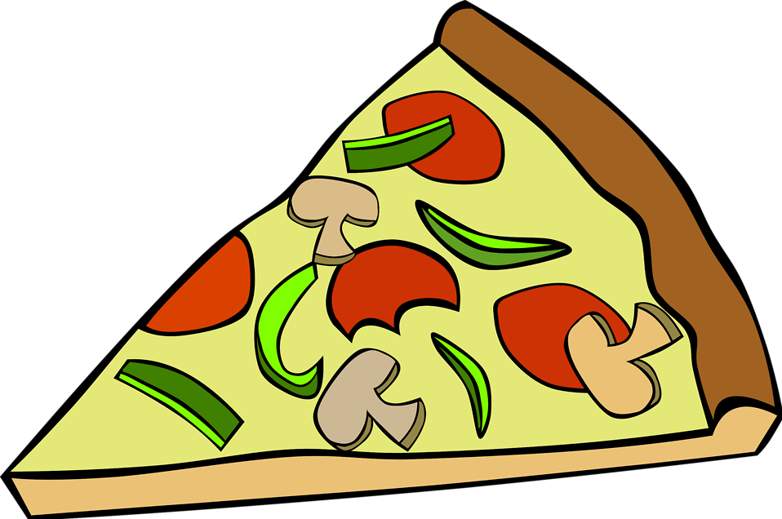  10:00-12:00 Exercise Time  12:00 Pass Daily News  1:00-2:00 Friendly Visits  1:30-2:30 Daily Bingo Numbers  2:30-3:30 Pizza Dice Game  3:30-4:15 Pizza Treat  6:00 Room to Room Activities | Coffyn (Pie) Day  9:00 Morning Joe & Cocoa Cart  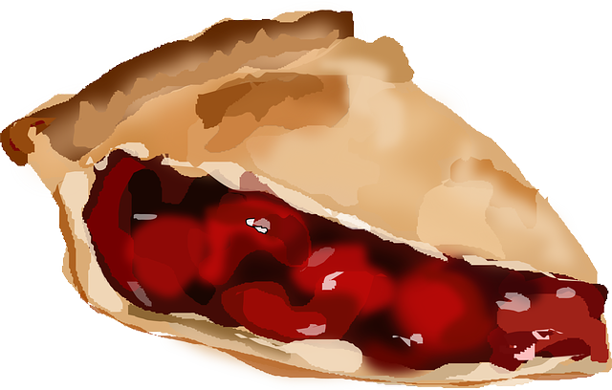  10:00-12:00 Game Time  12:00 Pass Daily News  1:00-2:00 Friendly Visits  1:30-2:30 Daily Bingo Numbers  2:30-3:30 Heart Wreath Craft  3:30-4:15 Coffyn (Pie) Treat  6:00 Room to Room Activities | Don’t Cry Over  Spilled Milk Day  9:00 Morning Joe & Cocoa Cart  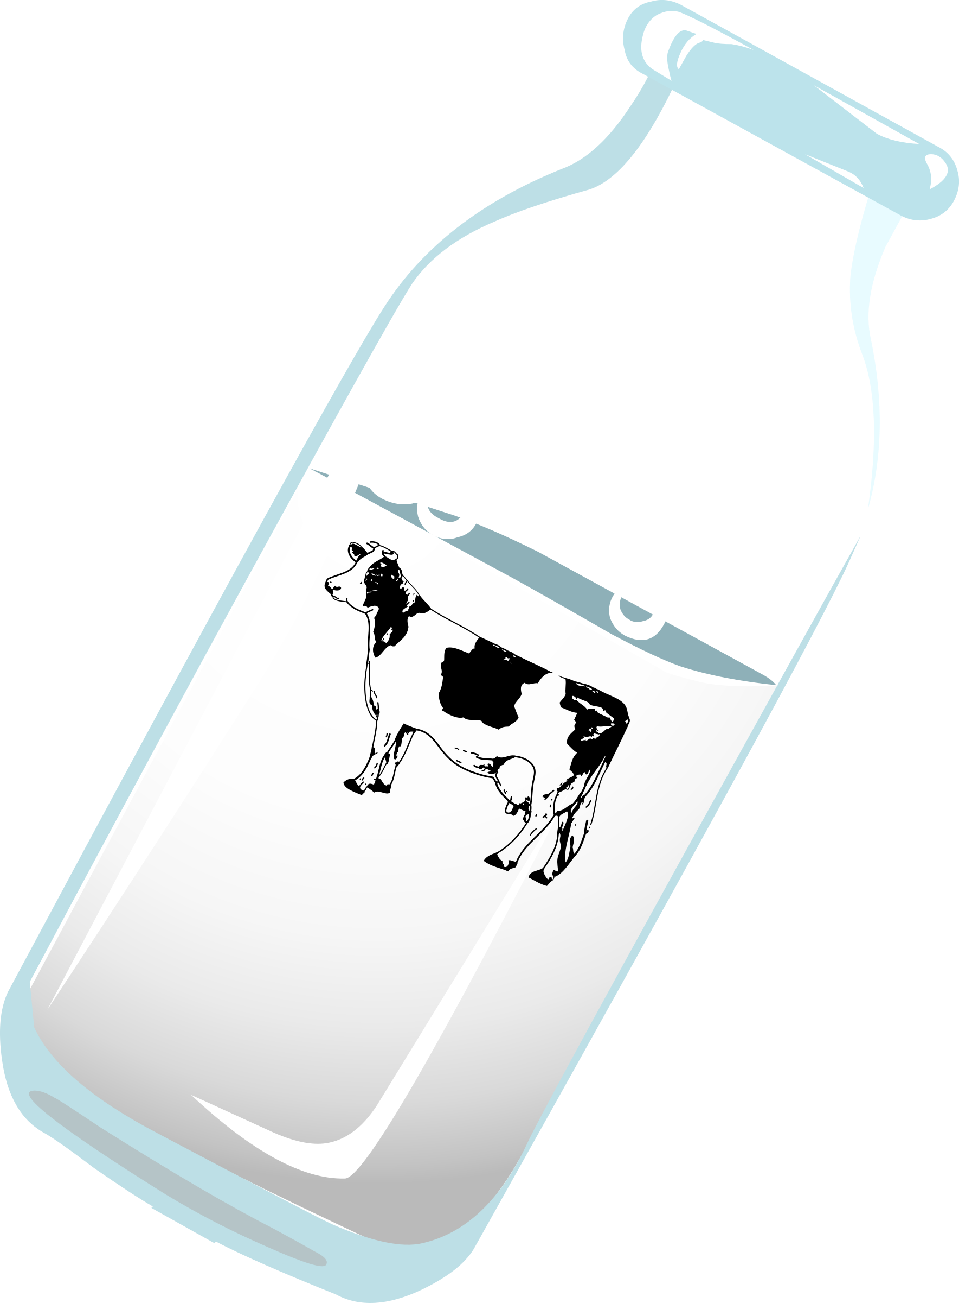  10:00-12:00 Game Time  12:00 Pass Daily News  1:00-2:00 Friendly Visits  1:30-2:30 Daily Bingo Numbers  2:30-4:15 Nail Care  3:30-4:15 Cookies and Milk Treat  6:00 Valentine’s Day Craft | Chinese New Year  9:00 Morning Joe & Cocoa Cart    10:00-12:00 Game Time  12:00 Pass Daily News  1:00-2:00 Friendly Visits  1:30-2:30 Daily Bingo Numbers  2:30-3:30 Fun Facts on China  3:30-4:15 Egg Roll Treat  6:00 Cherry Blossom Tree Craft | 9:00 Pass Daily News & Puzzle Packets  10:00 Morning Joe & Cocoa Cart  11:00-12:00 Friendly Visits  2:30-4:00 Game Time
Happy Valentine’s Day  10:00 Morning Joe & Cocoa Cart/Pass Devotionals  11:00-12:00 Friendly Visits  2:30-4:00 Gnome Craft   | Presidents Day  9:00 Morning Joe & Cocoa Cart  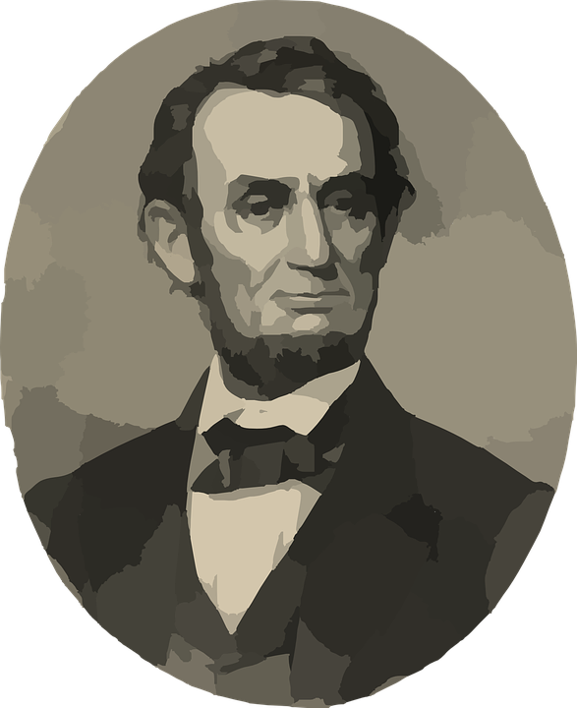  10:00-12:00 Game Time  12:00 Pass Daily News  1:00-2:00 Friendly Visits  1:30-2:30 Daily Bingo Numbers  2:30-3:30 Presidential Quotes  3:30-4:15 President Photo Shoot  6:00 Room to Room Activities | Mardi Gras  9:00 Morning Joe & Cocoa Cart    10:00-12:00 Exercise Time  12:00 Pass Daily News  1:00-2:00 Friendly Visits  1:30-2:30 Daily Bingo Numbers  2:30-3:30 Mardi Gras Parade  3:30-4:15 Monthly Birthday Treat  6:00 Mardi Gras Craft | Beer and Burger Day  9:00 Morning Joe & Cocoa Cart  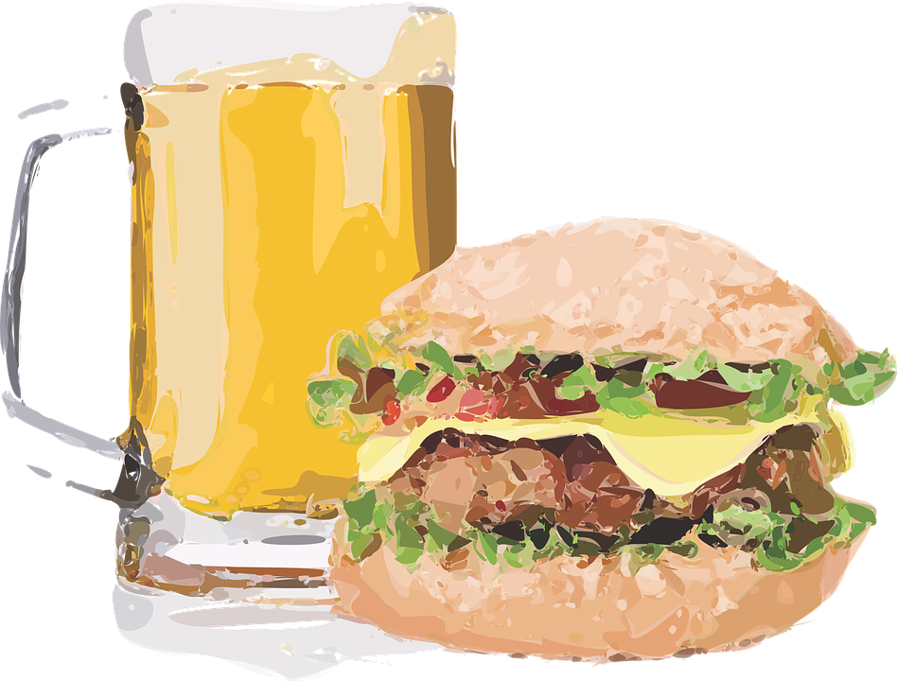  10:00-12:00 Game Time  12:00 Pass Daily News  1:00-2:00 Friendly Visits  1:30-2:30 Daily Bingo Numbers  2:30-3:30 History of the Burger  3:30-4:15 Burger Slider Treat  6:00 Room to Room Activities | Drink Wine Day  9:00 Morning Joe & Cocoa Cart    10:00-12:00 Game Time  12:00 Pass Daily News  1:00-2:00 Friendly Visits  1:30-2:30 Daily Bingo Numbers  2:30-4:15 Nail Care  3:30-4:15 Grape Juice Treat  6:00 Room to Room Activities | Chocolate Mint Day  9:00 Morning Joe & Cocoa Cart    10:00-12:00 Game Time  12:00 Pass Daily News  1:00-2:00 Friendly Visits  1:30-2:30 Daily Bingo Numbers  2:30-3:30 Popcorn For All  3:30-4:15 Peppermint Patty Snack  6:00 Room to Room Activities | 9:00 Pass Daily News & Puzzle Packets  10:00 Morning Joe & Cocoa Cart  11:00-12:00 Friendly Visits  2:30-4:00 Game Time
10:00 Morning Joe & Cocoa Cart/Pass Devotionals  11:00-12:00 Friendly Visits  2:30-4:00 Game Time | Would You Rather Day  9:00 Morning Joe & Cocoa Cart    10:00-12:00 Game Time  12:00 Pass Daily News  1:00-2:00 Friendly Visits  1:30-2:30 Daily Bingo Numbers  2:30-3:30 Would You Rather Game  3:30-4:15 Would You Rather Treat  6:00 Room to Room Activities | Girl Scout Cookie Day  9:00 Morning Joe & Cocoa Cart    10:00-12:00 Exercise Time  12:00 Pass Daily News  1:00-2:00 Friendly Visits  1:30-2:30 Daily Bingo Numbers  2:00 Rm-to-Rm Resident Council  2:30-3:30 Remembering Girl Scouts  3:30-4:15 Girl Scout Cookie Treat  6:00 Room to Room Activities | Tortilla Chip Day  9:00 Morning Joe & Cocoa Cart  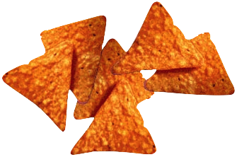  10:00-12:00 Game Time  12:00 Pass Daily News  1:00-2:00 Friendly Visits  1:30-2:30 Daily Bingo Numbers  2:30-3:30 I Spy on the iPad  3:30-4:15 Tortilla Chip Treat  6:00 Room to Room Activities | Chocolate Covered  Nuts Day  9:00 Morning Joe & Cocoa Cart  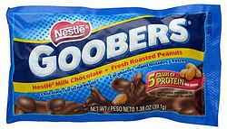  10:00-12:00 Game Time  12:00 Pass Daily News  1:00-2:00 Friendly Visits  1:30-2:30 Daily Bingo Numbers  2:30-4:15 Nail Care  3:30-4:15 Choco Covered Nut Treat  6:00 Room to Room Activities | Flap Jack Friday  9:00 Morning Joe & Cocoa Cart  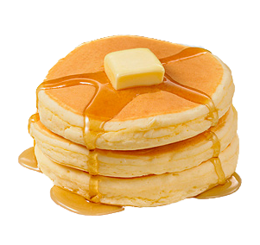  10:00-12:00 Game Time  12:00 Pass Daily News  1:00-2:00 Friendly Visits  1:30-2:30 Daily Bingo Numbers  2:30-3:30 Reminisce Stories  3:30-4:15 Flap Jack Treat  6:00 Room to Room Activities | 9:00 Pass Daily News & Puzzle Packets  10:00 Morning Joe & Cocoa Cart  11:00-12:00 Friendly Visits  2:30-4:00 Game Time
10:00 Morning Joe & Cocoa Cart/Pass Devotionals  11:00-12:00 Friendly Visits  2:30-4:00 Game Time | Oakview Medical Care Facility

Activities and times are subject to change. Changes will be posted as soon as possible. Large Print calendars are available upon request

