Sunday | Monday | Tuesday | Wednesday | Thursday | Friday | Saturday
 |  |  |  |  | 1  New Year’s Day | 2
3 | 4 | 5 | 6 | 7 | 8 | 9
10 | 11 | 12 | 13 | 14 | 15 | 16
17 | 18  Martin Luther King Day | 19 | 20 | 21 | 22 | 23
24  Activity Professionals Week | 25 | 26  Australia Day (observed) | 27 | 28 | 29 | 30
31

Oakview Medical Care Facility |  |  |  |  | Happy New Year!  9:00 New Year’s Morning Cup of  Joe & Cocoa Cart  10:00-12:00 Cover All Game  1:30-2:30 Daily Bingo Numbers    3: 30-4:15 Cheese and Crackers | 9:00 Pass Daily News & Puzzle Packets  10:00 Morning Joe & Cocoa Cart  11:00-12:00 Friendly Visits  2:30-4:00 Game Time
10:00 Morning Joe & Cocoa Cart/Pass devotionals  11:00-12:00 Friendly Visits  2:30-4:00 Game Time | National Spaghetti Day  9:00 Morning Joe & Cocoa Cart    10:00-12:00 Game Time  12:00 Pass Daily News  1:00-2:00 Friendly Visits  1:30-2:30 Daily Bingo Numbers  2:30-3:30 You be the Judge  3:30-4:15 Spaghetti Day Treat  6:00 Room to Room Activities | National Trivia Day  9:00 Morning Joe & Cocoa Cart    10:00-12:00 Game Time  12:00 Pass Daily News  1:00-2:00 Friendly Visits  1:30-2:30 Daily Bingo Numbers  2:30-3:30 Roll a Snowman Game  3:30-4:15 Winter Trivia  6:00 Room to Room Activities | 9:00 Morning Joe & Cocoa Cart  10:00-12:00 Game Time    12:00 Pass Daily News  1:00-2:00 Friendly Visits  1:30-2:30 Daily Bingo Numbers  2:30-3:30 Yahtzee on the iPad  3:30-4:15 Snowball Treat  6:00 Room to Room Activities | 9:00 Morning Joe & Cocoa Cart  10:00-12:00 Game Time  12:00 Pass Daily News  1:00-2:00 Friendly Visits  1:30-2:30 Daily Bingo Numbers  2:30-4:15 Nail Care  3:30-4:15 Frosty’s Jell-O Treat  6:00 Room to Room Activities | 9:00 Morning Joe & Cocoa Cart    10:00-12:00 Game Time  12:00 Pass Daily News  1:00-2:00 Friendly Visits  1:30-2:30 Daily Bingo Numbers  2:30-3:30 Popcorn for All  3:30-4:15 Root Beer Floats  6:00 Room to Room Activities | 9:00 Pass Daily News & Puzzle Packets  10:00 Morning Joe & Cocoa Cart  11:00-12:00 Friendly Visits  2:30-4:00 Game Time
10:00 Morning Joe & Cocoa Cart/Pass devotionals  11:00-12:00 Friendly Visits  2:30-4:00 Game Time | 9:00 Morning Joe & Cocoa Cart  10:00-12:00 Game Time  12:00 Pass Daily News  1:00-2:00 Friendly Visits  1:30-2:30 Daily Bingo Numbers  2:30-3:30 Reminisce the Blizzard of  1978  3:30-4:15 Blizzard Treats  6:00 Room to Room Activities | 9:00 Morning Joe & Cocoa Cart  10:00-12:00 Game Time  12:00 Pass Daily News  1:00-2:00 Friendly Visits  1:30-2:30 Daily Bingo Numbers  2:30-3:30 Cover All  3:30-4:15 Monthly Birthday Treat  6:00 Room to Room Activities | 9:00 Morning Joe & Cocoa Cart  10:00-12:00 Game Time  12:00 Pass Daily News  1:00-2:00 Friendly Visits  1:30-2:30 Daily Bingo Numbers  2:30-3:30 Scrabble on the iPad  3:30-4:15 Long John Treat  6:00 Room to Room Activities | 9:00 Morning Joe & Cocoa Cart    10:00-12:00 Game Time  12:00 Pass Daily News  1:00-2:00 Friendly Visits  1:30-2:30 Daily Bingo Numbers  2:30-4:15 Nail Care  3:30-4:15 Ice Cream Sundae  6:00 Room to Room Activities | 9:00 Morning Joe & Cocoa Cart  10:00-12:00 Game Time  12:00 Pass Daily News  1:00-2:00 Friendly Visits  1:30-2:30 Daily Bingo Numbers  2:30-3:30 Connect 4 on iPad  3:30-4:15 Snowball Floats  6:00 Room to Room Activities | 9:00 Pass Daily News & Puzzle Packets  10:00 Morning Joe & Cocoa Cart  11:00-12:00 Friendly Visits  2:30-4:00 Game Time
10:00 Morning Joe & Cocoa Cart/Pass devotionals  11:00-12:00 Friendly Visits  2:30-4:00 Game Time | 9:00 Morning Joe & Cocoa Cart  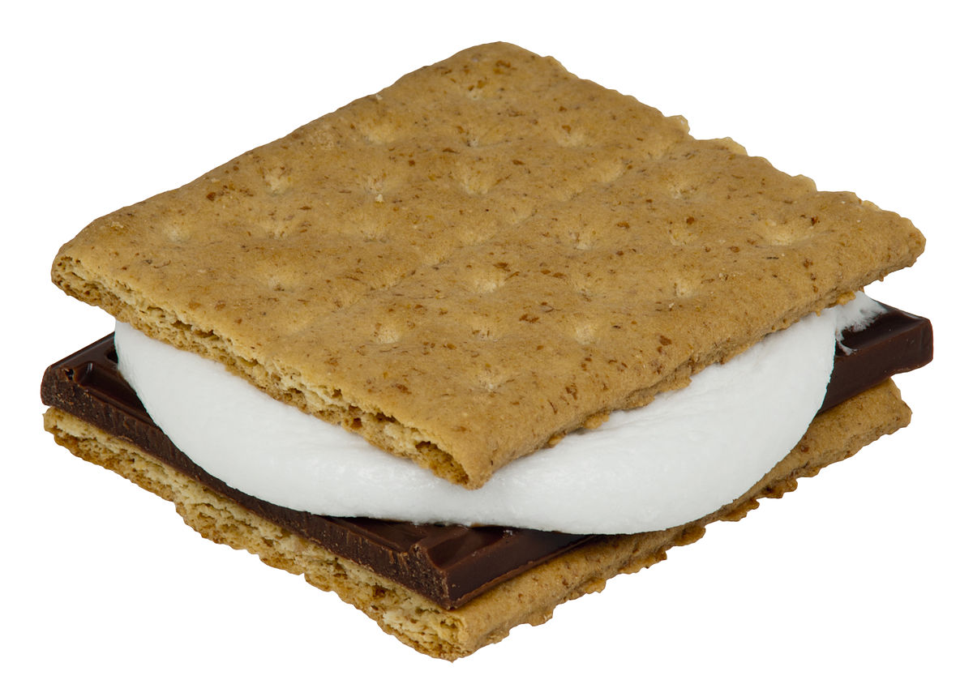  10:00-12:00 Game Time  12:00 Pass Daily News  1:00-2:00 Friendly Visits  1:30-2:30 Daily Bingo Numbers  2:30-3:30 Yahtzee on the iPad  3:30-4:15 Smores Snack  6:00 Room to Room Activities | National Popcorn Day  9:00 Morning Joe & Cocoa Cart  10:00-12:00 Game Time  12:00 Pass Daily News  1:00-2:00 Friendly Visits  1:30-2:30 Daily Bingo Numbers  2:30-3:30 kings in the Corner iPad  3:30-4:15 Popcorn for All  6:00 Room to Room Activities | National Cheese Lovers Day  9:00 Morning Joe & Cocoa Cart  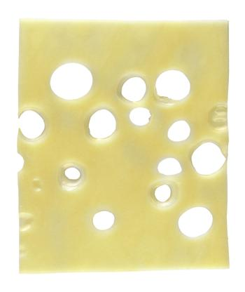  10:00-12:00 Game Time  12:00 Pass Daily News  1:00-2:00 Friendly Visits  1:30-2:30 Daily Bingo Numbers  2:30-3:30 Nature Trivia  3:30-4:15 Cheese Treat  6:00 Room to Room Activities | 9:00 Morning Joe & Cocoa Cart  10:00-12:00 Game Time  12:00 Pass Daily News  1:00-2:00 Friendly Visits  1:30-2:30 Daily Bingo Numbers  2:30-4:15 Nail Care  3:30-4:15 Trail Mix  6:00 Room to Room Activities | 9:00 Morning Joe & Cocoa Cart  10:00-12:00 Game Time  12:00 Pass Daily News  1:00-2:00 Friendly Visits  1:30-2:30 Daily Bingo Numbers  2:30-3:30 Sled Dog Craft  3:30-4:15 No Bake Cookie Snack  6:00 Room to Room Activities | 9:00 Pass Daily News & Puzzle Packets  10:00 Morning Joe & Cocoa Cart  11:00-12:00 Friendly Visits  2:30-4:00 Game Time
10:00 Morning Joe & Cocoa Cart/Pass devotionals  11:00-12:00 Friendly Visits  2:30-4:00 Game Time | 9:00 Morning Joe & Cocoa Cart    10:00-12:00 Game Time  12:00 Pass Daily News  1:00-2:00 Friendly Visits  1:30-2:30 Daily Bingo Numbers  2:30-3:30 Ski Lodge Craft  3:30-4:15 Baked Potato Bar Treat  6:00 Room to Room Activities | 9:00 Morning Joe & Cocoa Cart    10:00-12:00 Game Time  12:00 Pass Daily News  1:00-2:00 Friendly Visits  1:30-2:30 Daily Bingo Numbers  2:30-3:30 Name 5 Game  3:30-4:15 Chili Cup Treat  6:00 Room to Room Activities | 9:00 Morning Joe & Cocoa Cart  10:00-12:00 Game Time  12:00 Pass Daily News  1:00-2:00 Friendly Visits  1:30-2:30 Daily Bingo Numbers  2:30-3:30 Would You Rather Game  3:30-4:15 Bread Pudding  6:00 Room to Room Activities | 9:00 Morning Joe & Cocoa Cart    10:00-12:00 Game Time  12:00 Pass Daily News  1:00-2:00 Friendly Visits  1:30-2:30 Daily Bingo Numbers  2:30-4:15 Nail Care  3:30-4:15 Soft Pretzel Treat  6:00 Room to Room Activities | 9:00 Morning Joe & Cocoa Cart    10:00-12:00 Game Time  12:00 Pass Daily News  1:00-2:00 Friendly Visits  1:30-2:30 Daily Bingo Numbers  2:30-3:30 Cocoa Craft  3:30-4:15 Hot Chocolate  6:00 Room to Room Activities | 9:00 Pass Daily News & Puzzle Packets  10:00 Morning Joe & Cocoa Cart  11:00-12:00 Friendly Visits  2:30-4:00 Game Time
10:00 Morning Joe & Cocoa Cart/Pass devotionals  11:00-12:00 Friendly Visits  2:30-4:00 Game Time | All Activities are in-room and 1:1 with Activity staff at this time.

Activities and times are subject to change. Changes will be posted as soon as possible. Large Print calendars are available upon request

